High Level Use Case Diagrams

Task 2 – Use case

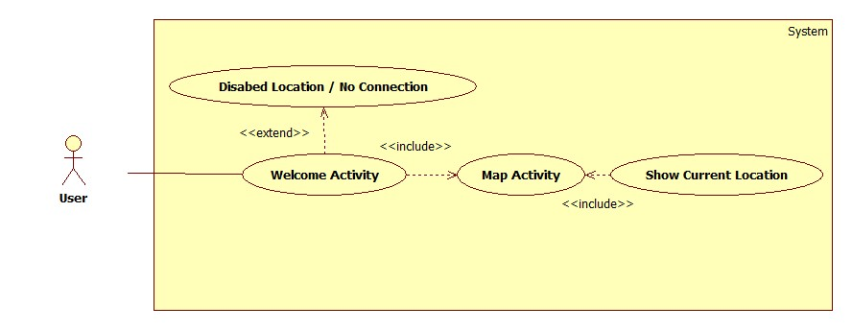

Figure 1 - The diagram shows the typical activity user will perform in task 2.

Task 3 – Use case

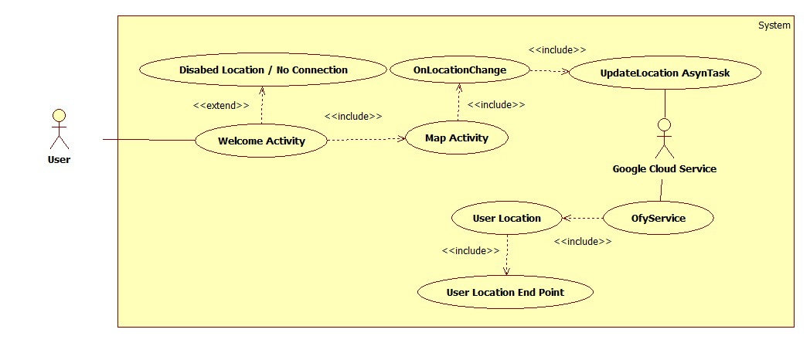

Figure 2 - The diagram shows the typical activity user will perform in task 3.

Task 4 – Use case

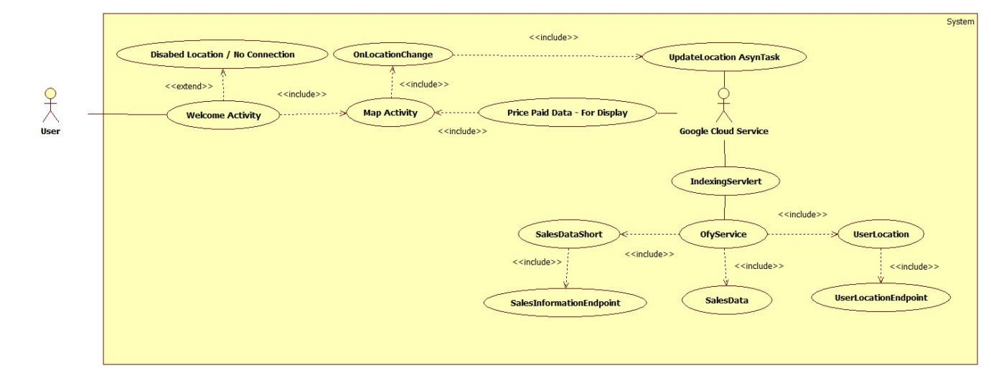

Figure 3 - The diagram shows the typical activity user will perform in task 4.

Activity diagrams

Task 2 – Activity diagram

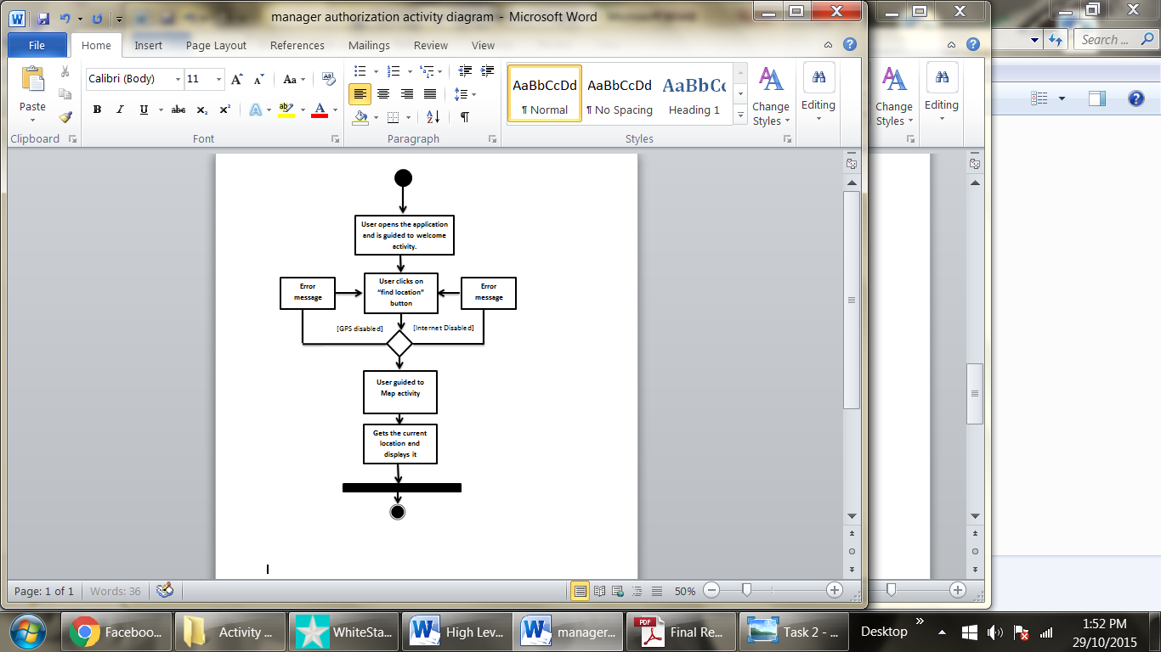

Figure 4 – This shows the activity diagram for task 2 from user clicking on “find location” button to application displaying the current location.

Task 3- Activity diagram

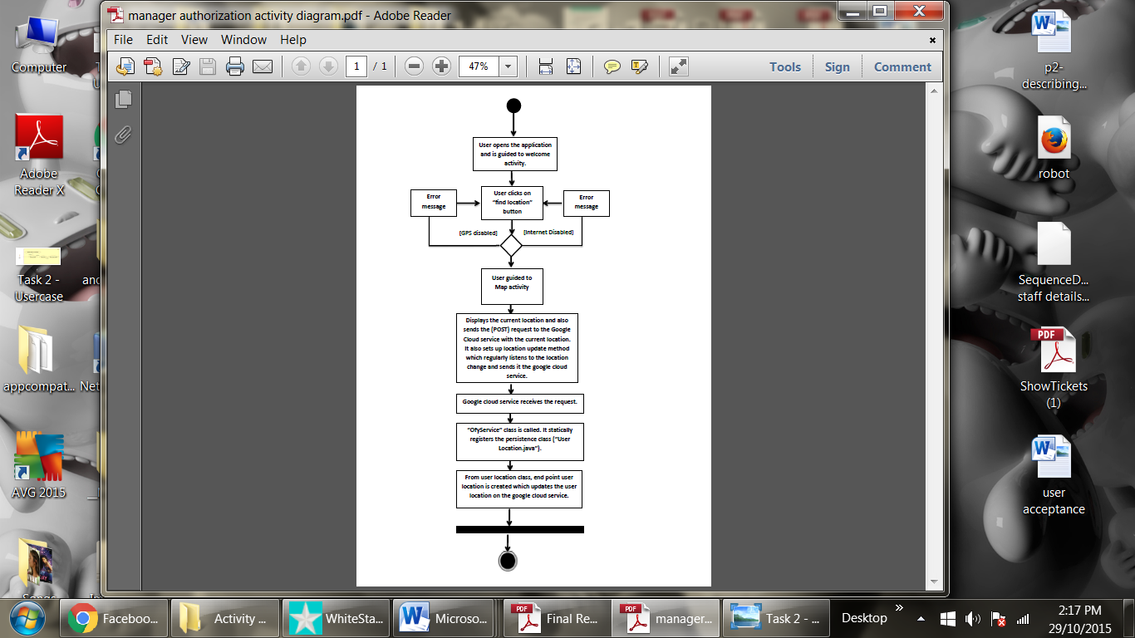

Figure 5 – This shows the activity diagram for task 3 from user clicking on “find location” button to application registering the current location (longitude and latitude) on google cloud service.

Task 4- Activity diagram

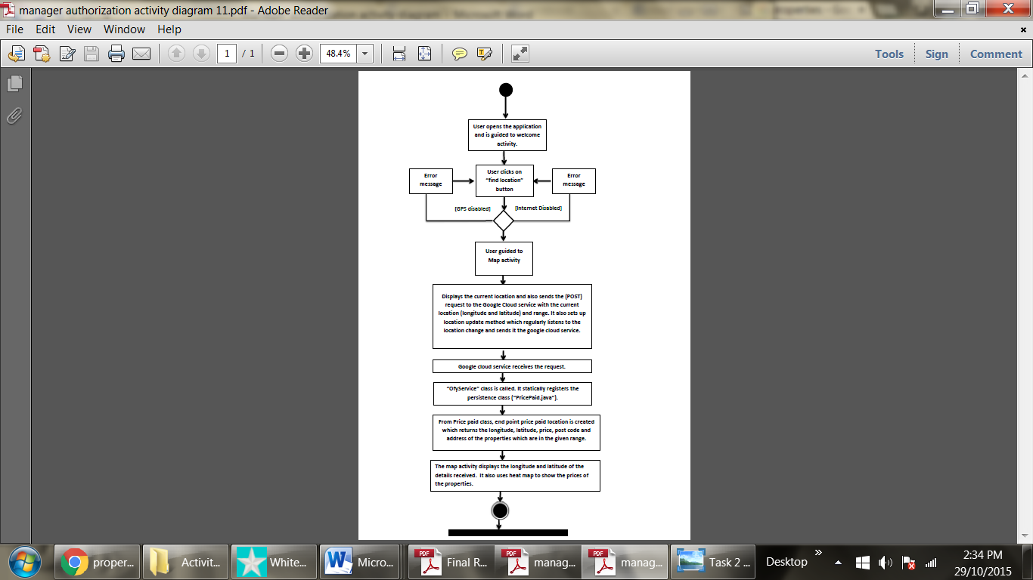

Figure 5 – This shows the activity diagram for task 4 from user clicking on “find location” button to application getting the information about properties in the given range from google cloud storage.

Class diagrams

Task 2 – Class Diagram

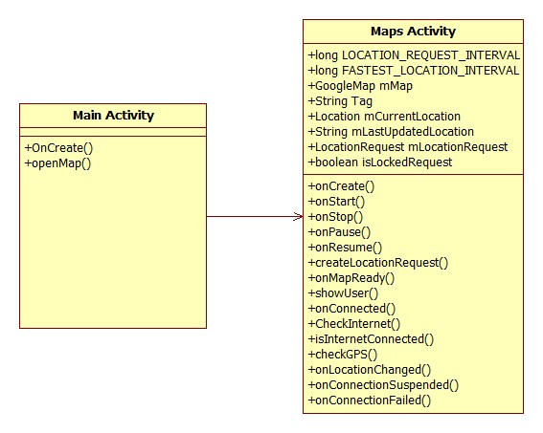

Figure 6 – This shows the class diagram for task 2.

Task 3 – Class Diagram

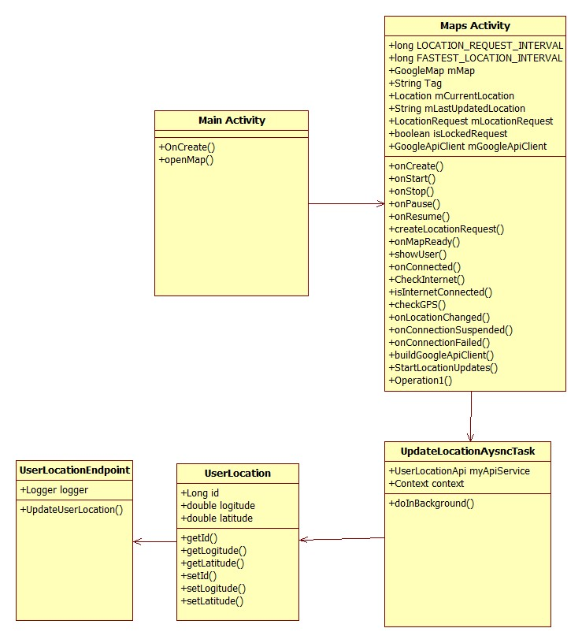

Figure 7 – This shows the class diagram for task 3.

Task 4 – Class Diagram

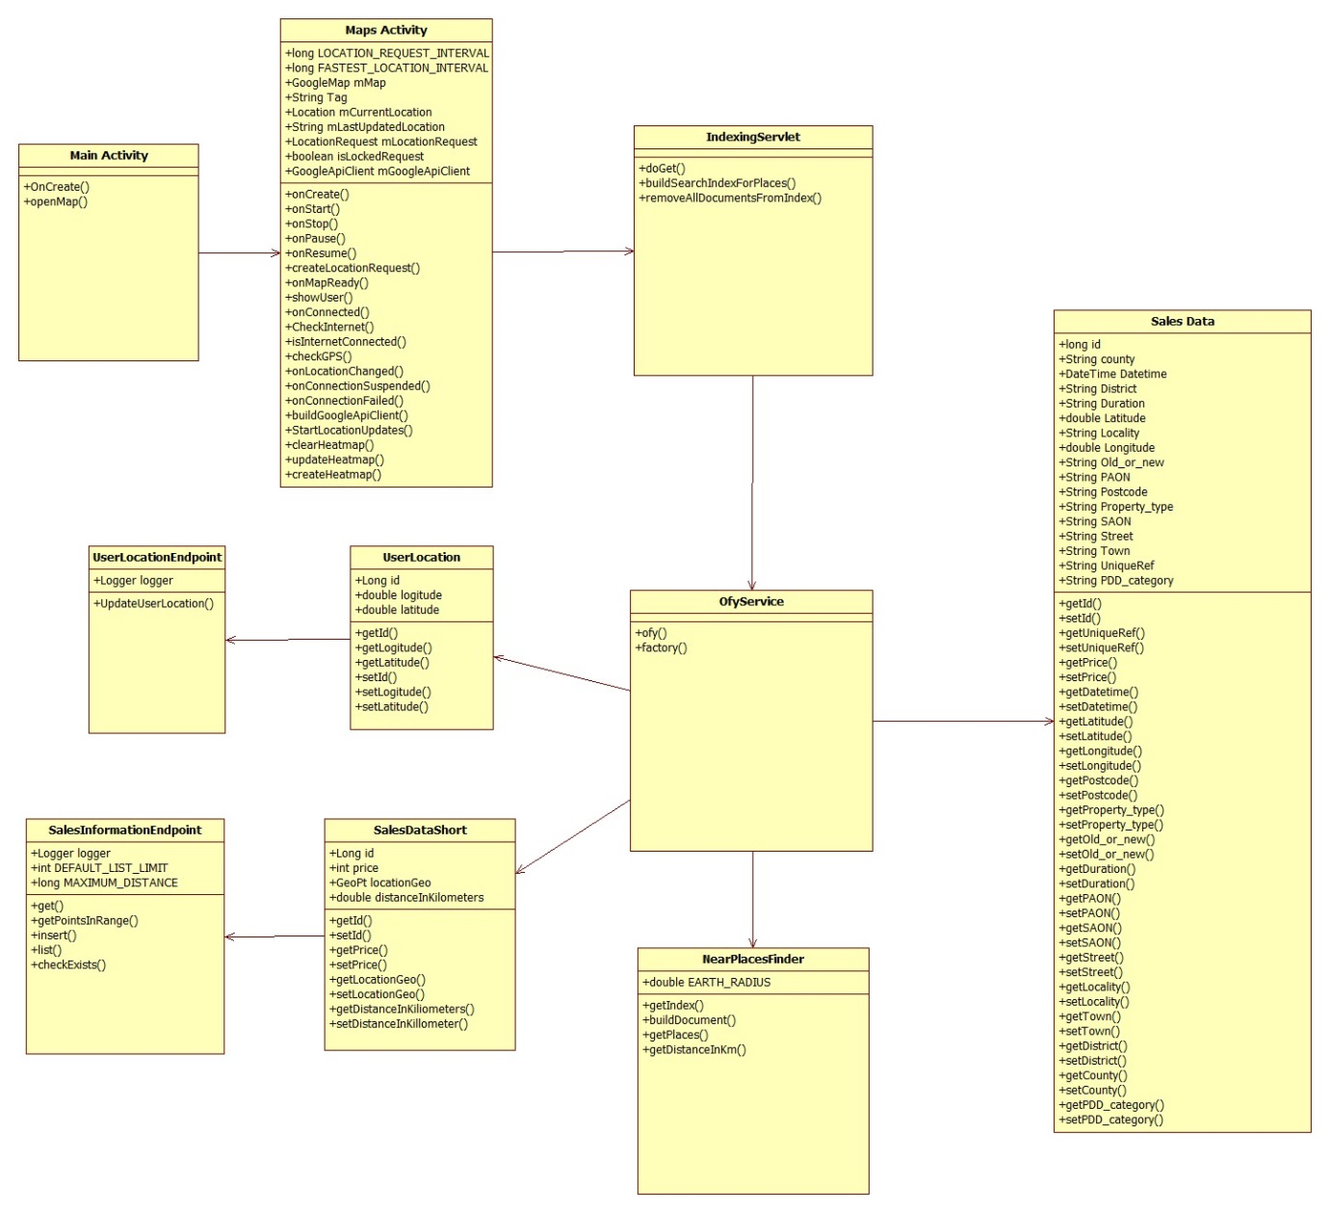

Figure 8 – This shows the class diagram for task 4.